

The intrinsic and damped Ly-**α**profiles for GJ1132. These plotted spectra are saved in the requested table, where the intrinsic profile is converted to the flux at 1AU (shown here it is at 12.04 pc). Total integrated Lyman-alpha flux is 3.43x10-14 erg/cm2/s.



EUV spectrum based on the Linksy relations. **The EUV luminosity (100-912 Angstrom) was calculated to be 4.957x1026 erg/s.**

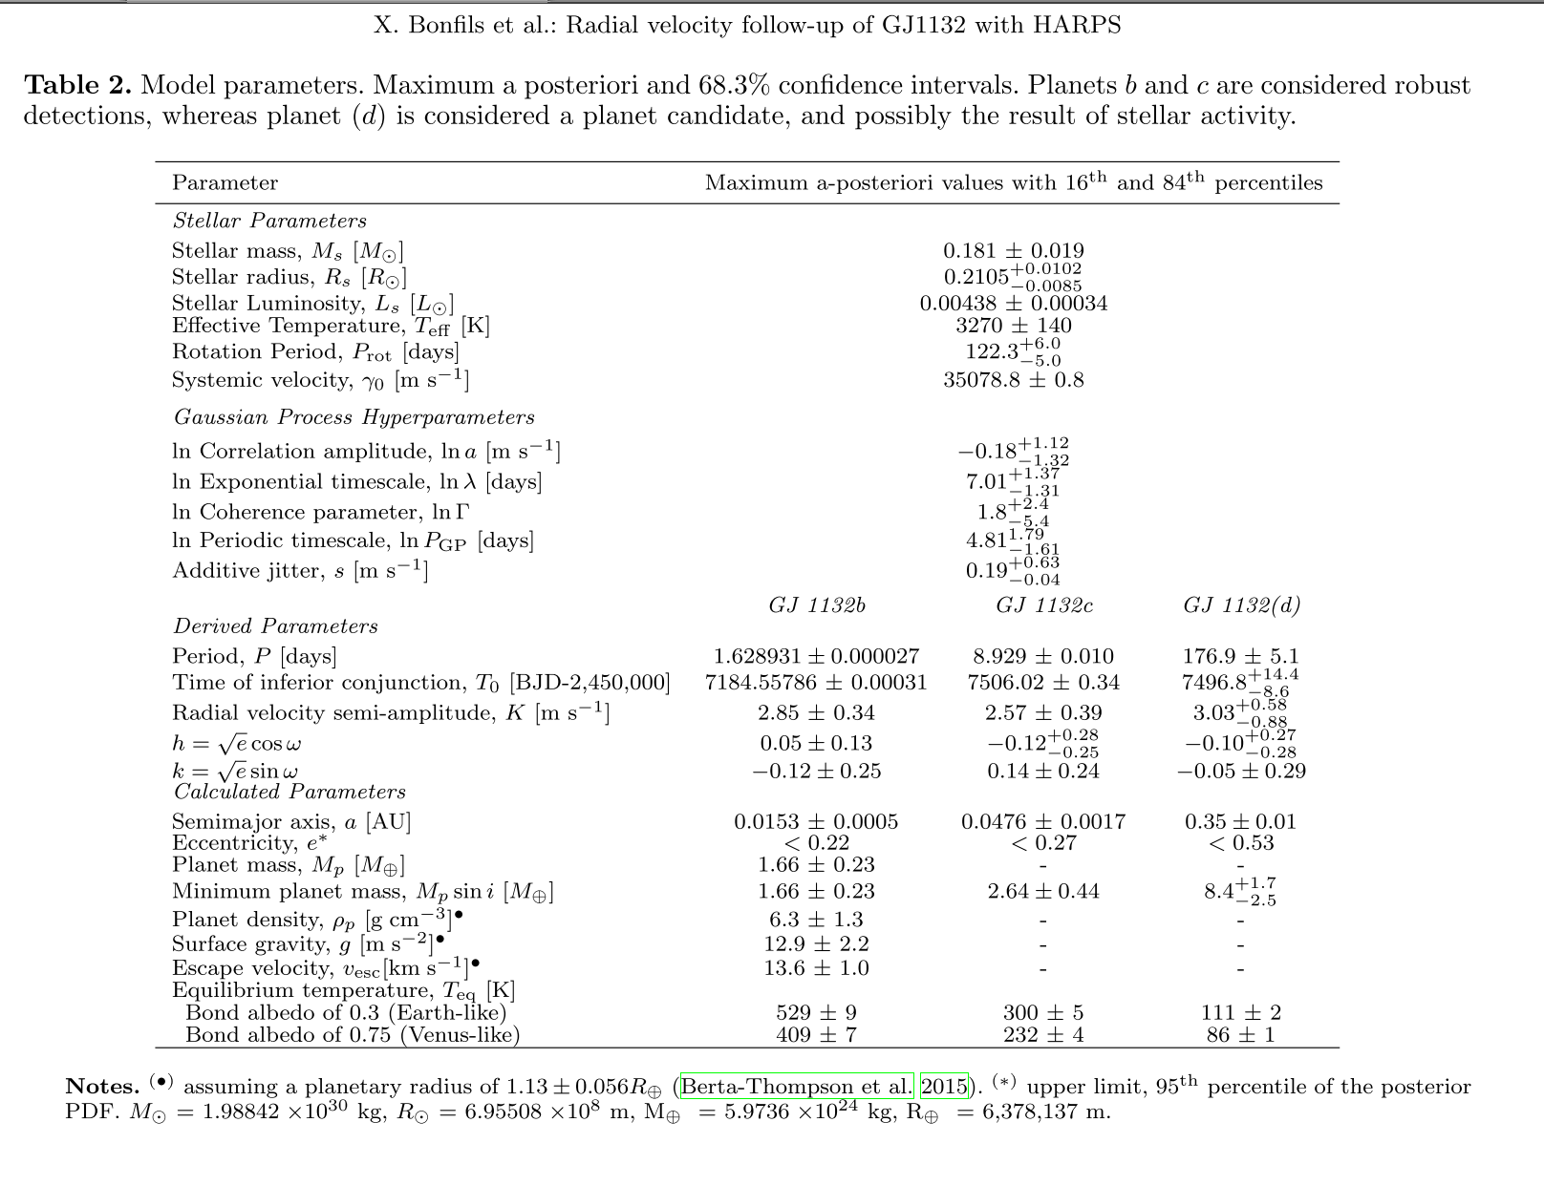

You can assume that planet and star parameters from the most recent publication on this system are consistent with most values I use at all stages of this project, with the exception of **planet and star radii, for which I adopt the values from Dittmann et al, 2017**:

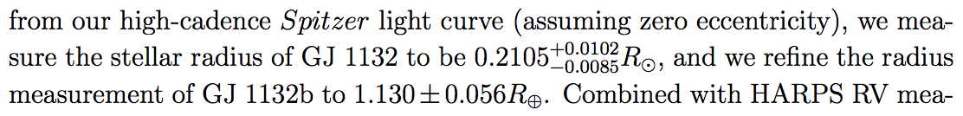

These values give us a surface gravity of 12.75 m/s2 for GJ1132b.

**In case it is usefuls, our modeling of the STIS light curves give us a 2-σupper limit Rp/R* of 0.36.**